**SQL ASSIGNMENT - 01**

**QUERY -1**

create database department;

use department;

create table items( name_of_items varchar(20) not null, rate_of_items int not null,customer_preference varchar (20) not null);

desc items;

select * from items;

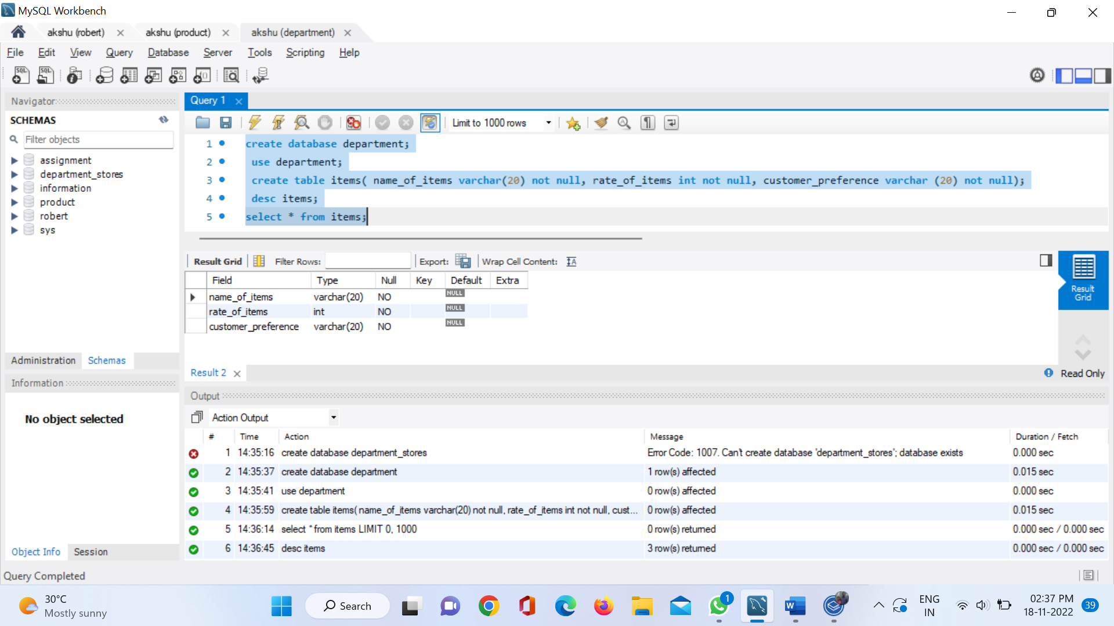

create database department_stores;

use department_stores;

create table items_list( name_of_items varchar(20) not null, rate_of_items int not null, customer_preference varchar (20));

INSERT INTO items_list(name_of_items,rate_of_items,customer_preference)

VALUES ('chocolate',2000,'mostly prefered'),

('biscuit',2500,'prefered'),

('chips',1000,'prefered');

select * from items_list;

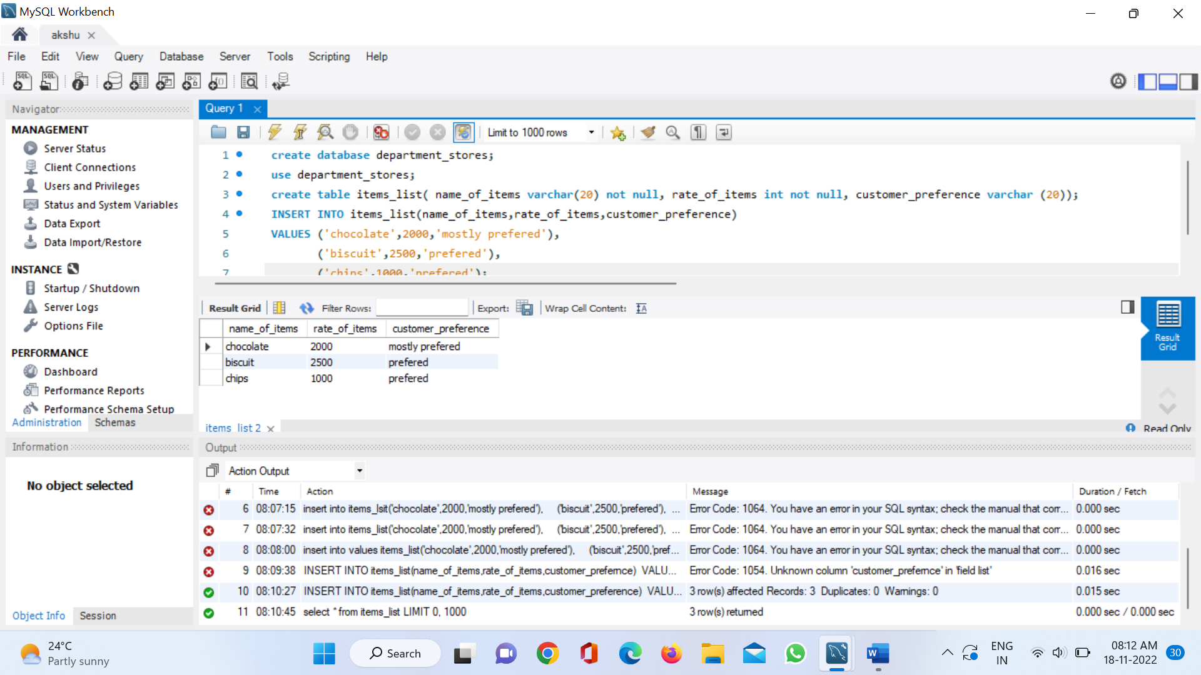

**QUERY -2**

create database alagu;

use alagu;

create table sales(column_ID int not null,product_name varchar(40) not null,price_per_unit int not null,Quantity int not null);

insert into sales values (101,'chocolate',1000,20),(102,'biscuit',1500,15),(103,'chicken',2000,25),(104,'mutton',3000,40);

select* from sales;

create view myviews as select product_name,price_per_unit*quantity as Total_cost from sales;

select* from myviews;

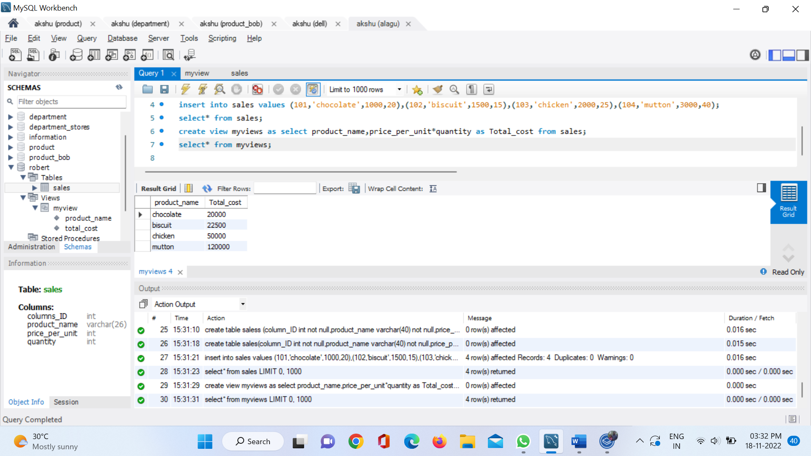

**QUERY -3**

create database product;

use product;

create table students_info(id int not null, Nam varchar(40) not null, age int not null);

INSERT INTO students_info (id,Nam,age)

VALUES (1,'BOb',21),(2,'Sam',19),(3,'Jill',18),(4,'Jim',21),(5,'Sally',19),(6,'Jess',20),(7,'Will',21);

select *from students_info;

select sum(age) from students_info;

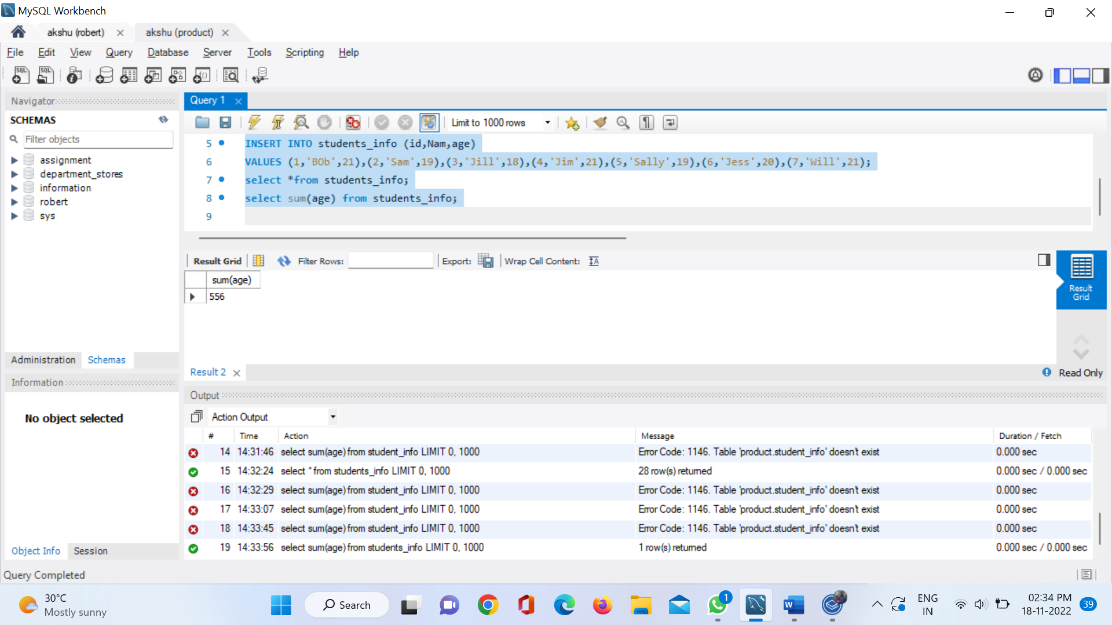

**QUERY -4**

create database product_bob;

use product_bob;

create table students_infom(id int not null, Nam varchar(40) not null, age int not null);

INSERT INTO students_infom (id,Nam,age)

VALUES (1,'BOb',21),(2,'Sam',19),(3,'Jill',18),(4,'Jim',21),(5,'Sally',19),(6,'Jess',20),(7,'Will',21);

select *from students_infom;

select age , count(*) as count_age from students_infom group by age ;

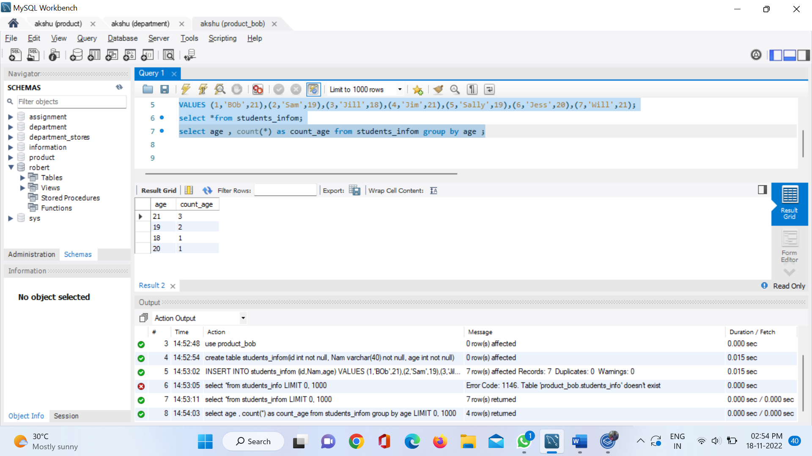

**QUERY -5**

create database dell;

use dell;

create table dell(Division_id int not null, years int not null, revenue float not null);

insert into dell values(1,2018,60),(1,2021,40),(1,2020,70),(2,2021,-10),(3,2018,20),(3,2016,40),(4,2021,50);

select Division_id from dell where revenue > 0 and years = 2021;

